**Explanation**

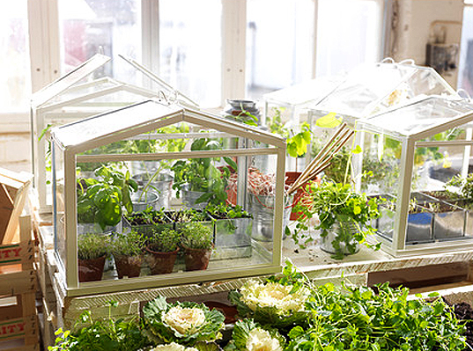

My IOT program is about “Indoor Planting”. It’s especially for growing flower in the small size of greenhouse people can put in their house. The goal of this indoor planting device is for detecting conditions of surrounding environment and helping to keep the good condition for plants. The device detects light, air temperature, and air humidity. if they go beyond the normal ranges, the IOT message send warning to owner. So, for example, the owner can turn off the heater or turn on the light following the IOT message.

My variables in the IOT message are three and I set ranges for each variable as below. I also separate specific ranges for sending different messages. If the variables go below or beyond the normal ranges, IOT send warning messages for each situation such as turn on or off the buttons for heater, light, blinder humidifier and dehumidifier. (It also sends message when it’s in the normal range.)

|  |  |  |
| --- | --- | --- |
| variables | range | Normal range |
| Light | 0 to 100 Watt | 40-50 watt |
| Humidity | 0- 100% | 50-60 % |
| Temperature | -40 to100 ºF | 65-75 ºF |

For the case of light, I divided ranges to 6 sections and send a mild to a strong warning. For example, If the light goes a little above the normal range (40-50W), it tells "Light is a little bit above the normal ranges but still OK. “. But if it goes up to 60 -80W, it sends a message like "Light is above the normal ranges. Raise the blinder. " If it goes beyond more than 80 W, it says "Raise the blinder immediately or your plants gonna die soon." Other variables such as humidity and temperature work in the same way as described in the case of the light variable.

In conclusion, this lOT message device helps people to grow plant indoor safely and easily. It detects surrounding environment and give a specific instruction for keeping good condition for plants. This device is defiantly needed because plant requires delicate conditions. I made this program especially for flowers. Its numerical figures are fitted to growing flowers.